Chapter 16, Problem 23.

Obtain v(t) for t > 0 in the circuit of Fig. 16.46.

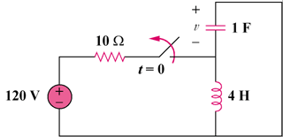
90 V

Figure 16.46
For Prob. 16.23.

